Chapter 10, Solution 46.

Solve for v_{o}(t) in the circuit of Fig. 10.91 using the superposition principle.

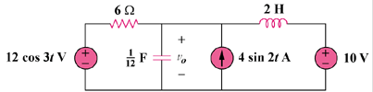

Figure 10.91
For Prob. 10.46.

Solution

Let , where , , and are respectively due to the 10-V dc source, the ac current source, and the ac voltage source. For consider the circuit in Fig. (a).

(a)

+

v₁

2 H

10 V

6
+

1/12 F

The capacitor is open to dc, while the inductor is a short circuit. Hence,

For , consider the circuit in Fig. (b).

-j6

(b)

+

V₂

6

j4

40 A
Applying nodal analysis,

Hence,

For , consider the circuit in Fig. (c).

j6

6

120 V
+

-j4

(c)

+

V₃

At the non-reference node,
Hence,

Therefore,
[10+21.45sin(2t+26.56)+10.73cos(3t–26.56)] V

